Appendix 3 Model fit and model comparison

In Figure A3.1 we show the one step ahead predictions of the model for the growth rates of GDP (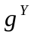), consumption (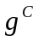), investment (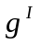), labour (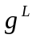), government consumption (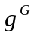), government investment (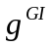), government transfers (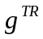), as well as for inflations (, 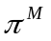,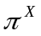), wage inflation (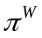), growth rate of investment specific technological progress (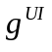), nominal interest rates (, 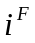), nominal exchange rate (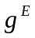), world inflation (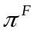), world GDP (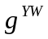).
We also show the fit of nominal ratios to GDP of consumption (cyn), government consumption (cgyn), government investment (igyn), investment (iyn), trade balance (tbyn), transfers to wages ratio (trw), the real foreign GDP to domestic GDP ratio (ywy) as well as the stationary real exchange rate (ER), labour (L), wage share (ws), import to GDP deflator (PM/P), export to GDP deflator (PX/P).

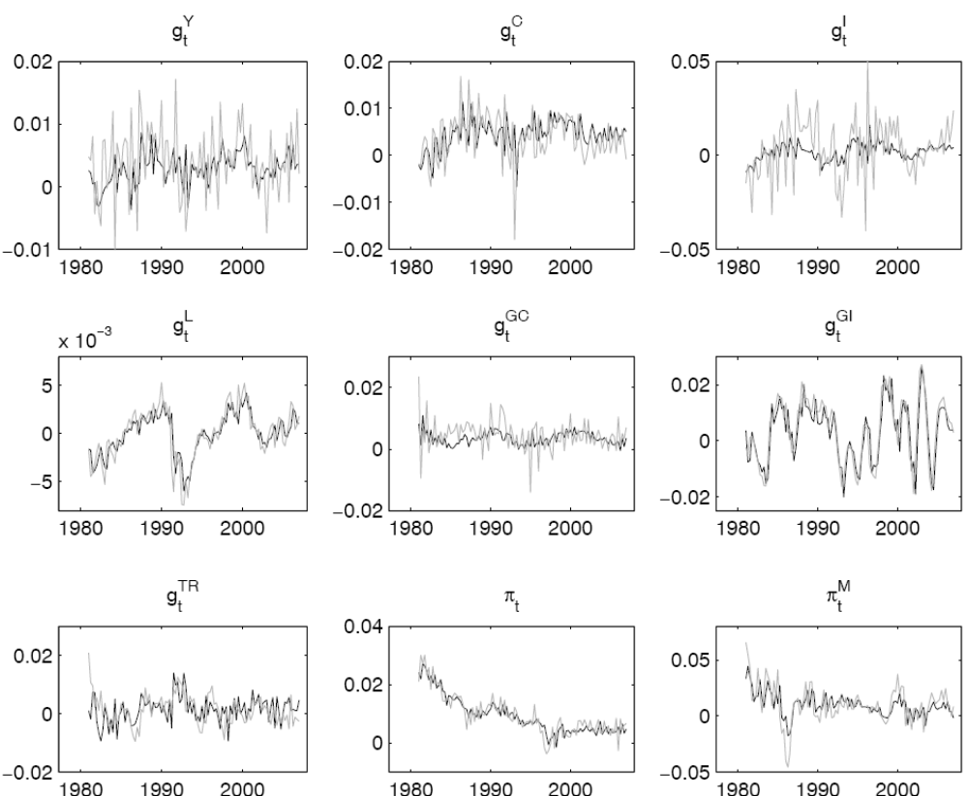
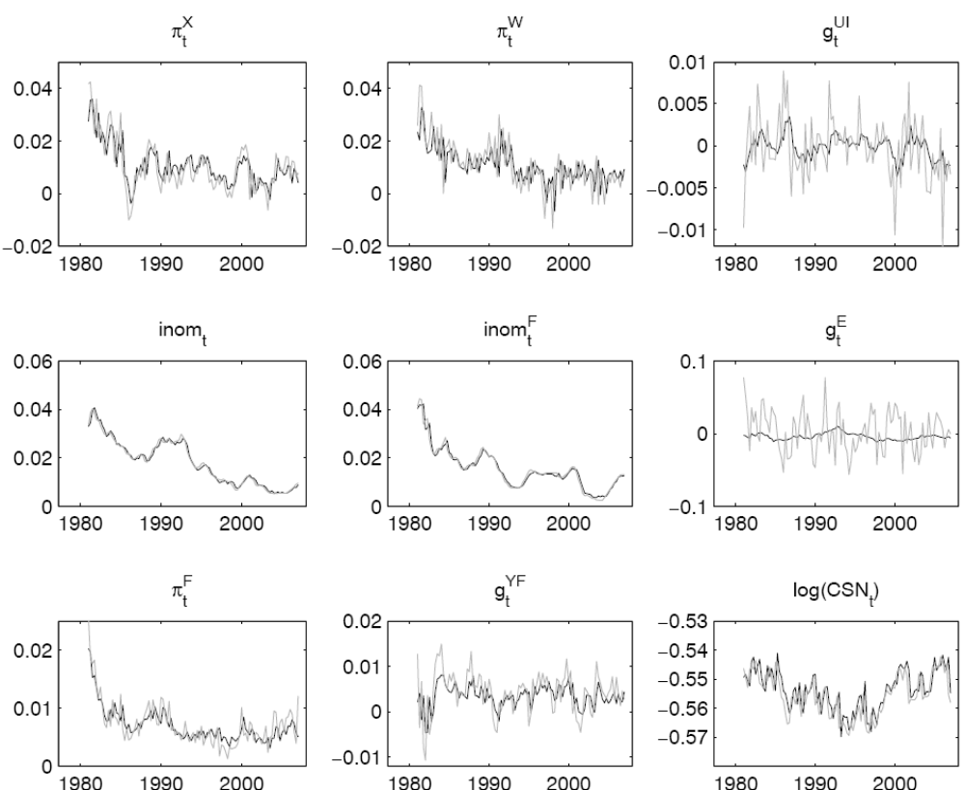
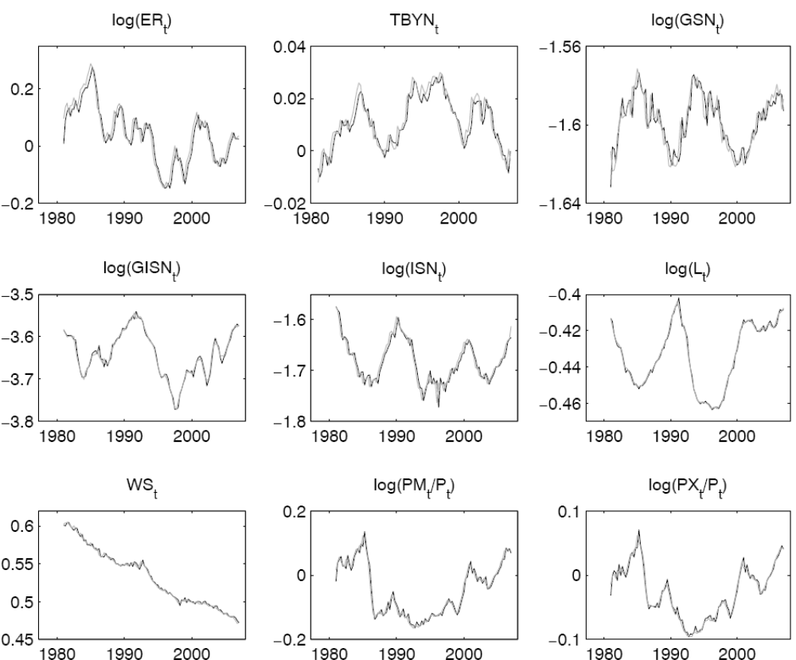
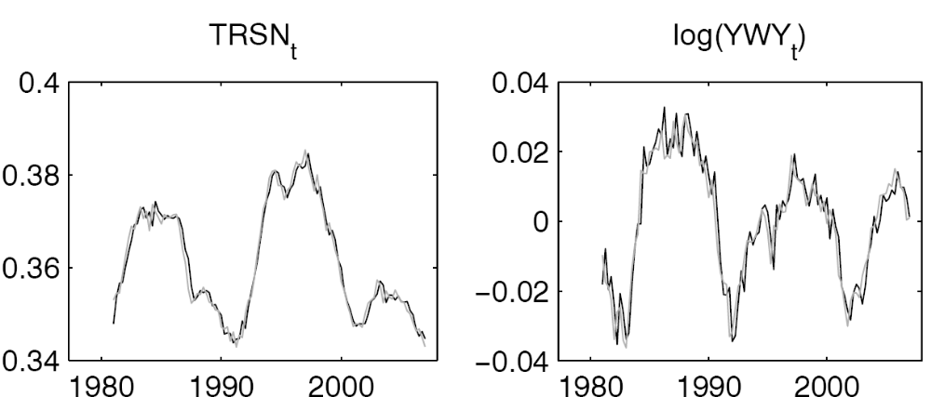

FIGURE A.3.1. In-sample one step ahead predictions of the estimated model. (Data are grey lines; model predictions are black lines)

A quite widely applied method to assess the validity of the estimated DSGE models is to compare them with non-structural linear reduced-form models such as VARs or BVARs (see e.g. Sims, 2003; Schorfheide, 2004; Smets and Woutyers, 2003; Juillard et al. 2006). In Table A3.1 we compare our base model with BVAR models (lags 1 to 12) using Sims and Zha (1998) priors. The BVAR estimates were obtained following Juillard et al. (2006), combining the Minnesota prior with dummy observations. The prior decay and tightness parameters are set to 0.5 and 3, respectively. As in Juillard et al. (2006), the parameter determining the weight on own-persistence (sum-of-coefficients on own lags) is set at 2 and the parameter determining the degree of co-persistence is set at 5. To obtain priors for error terms we used the residuals from unconstrained AR(1) processes estimated over a sample of observations that was extended back to 1978Q1 (the DSGE model is estimated over a sample starting from 1981Q1). The marginal data density of the DSGE has been obtained from the two-chain, 300,000 replications of the Metropolis-Hastings Algorithm using the modified harmonic mean formula suggested by Geweke. Similarly to other estimated DSGE’s in the literature, our base model has a better marginal likelihood than BVAR’s. Although the robustness of these kinds of results is sometimes criticized, for the reason that it may depend on different prior assumptions in both the DSGE and the BVAR, BVARs are a potentially useful metric for comparing the out-of-sample performance of DSGE models.

TABLE A3.1 Comparison of the fit of the base model and of BVAR’s.

 | Marginal likelihood
BVAR(1) | 6752.695
BVAR(2) | 6835.592
BVAR(3) | 6831.757
BVAR(4) | 6835.782
BVAR(5) | 6836.935
BVAR(6) | 6828.311
BVAR(7) | 6837.512
BVAR(8) | 6835.597
BVAR(9) | 6835.392
BVAR(10) | 6827.01
BVAR(11) | 6825.155
BVAR(12) | 6829.694
DSGE model | 7066.91

In Table A3.2 we also report the RSME’s of the 1-step and 4-step ahead predictions of the DSGE model and of a VAR(1) that includes error corrections mimicking the long run restrictions implied by the model concerning nominal ratios. In Figure A3.2 we also show the plots of the 1-step ahead fit of the VAR(1). The in-sample RMSE’s of the VAR(1) are obviously better than those of the DSGE, and they are useful to have an idea of the ‘upper’ bound of the in-sample fit. This does not obviously imply a better performance of the VAR out-of-sample (see above discussion on BVAR comparison). It is interesting to note that for most of the observed variables, the DSGE performs better in the 4-step than in the 1-step ahead prediction horizons.

TABLE A3.2 Comparison of the fit of the base model and a VAR(1) with error error corrections reproducing long run constraints of the DSGE model. RMSE’s are reported for 1-step and 4-step ahead predictions.

 | DSGE  1-step | VAR(1)  1-step | DSGE  4-step | VAR(1)  4-step
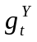 | 0.005581 | 0.003838 | 0.005459 | 0.00482
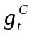 | 0.005357 | 0.00349 | 0.00501 | 0.004114
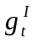 | 0.015205 | 0.010913 | 0.014945 | 0.013367
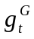 | 0.00462 | 0.0037 | 0.00443 | 0.004028
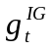 | 0.005466 | 0.003365 | 0.011552 | 0.00761
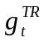 | 0.005454 | 0.002583 | 0.005077 | 0.00341
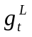 | 0.001489 | 0.001214 | 0.002099 | 0.001488
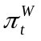 | 0.007895 | 0.004743 | 0.007112 | 0.00552
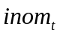 | 0.001156 | 0.00086 | 0.002804 | 0.00162
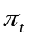 | 0.003208 | 0.002401 | 0.003706 | 0.00290
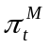 | 0.012617 | 0.009285 | 0.014677 | 0.01213
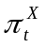 | 0.006065 | 0.004675 | 0.00728 | 0.00582
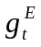 | 0.02927 | 0.020961 | 0.027276 | 0.024352

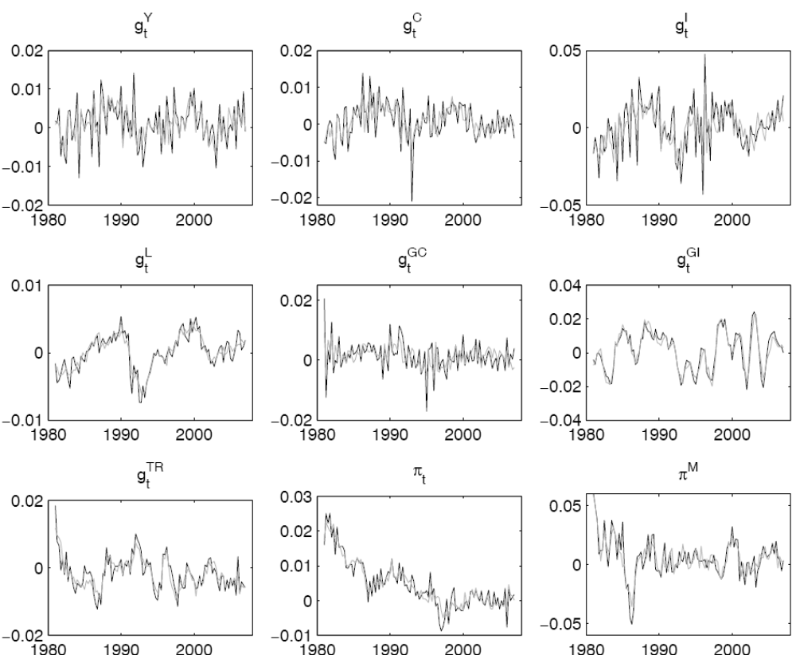
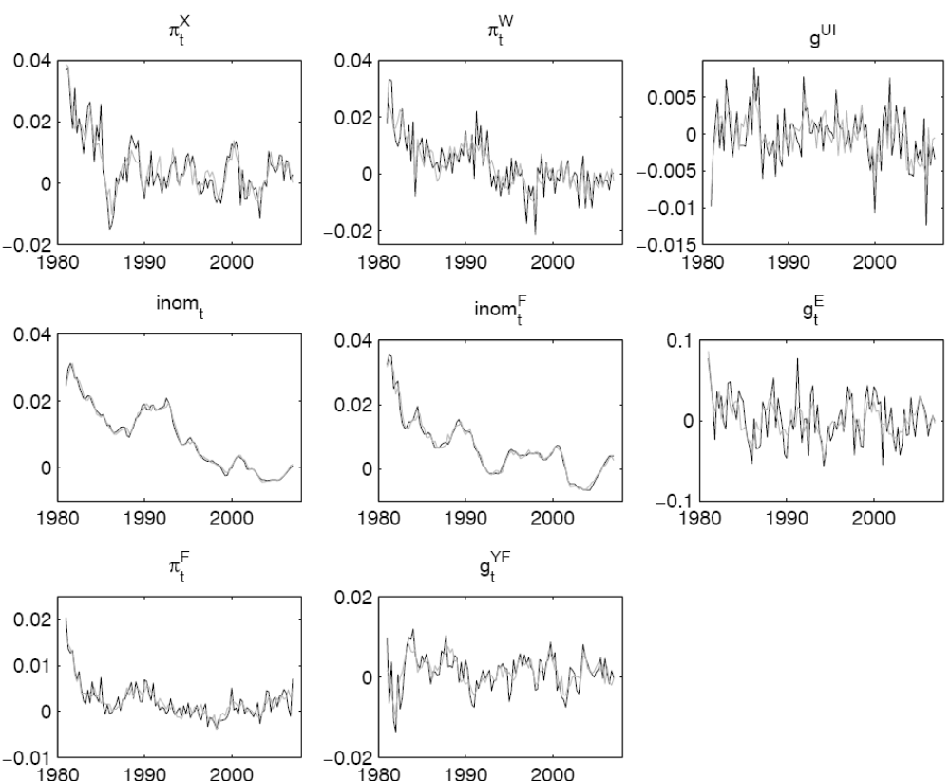

FIGURE A3.2: fit of a VAR(1) including VECM corrections matching those implied by the DSGE model.

Variance decomposition

Tables A3.3-3.5 show the posterior intervals of the variance decomposition for conditional variance (1-step and 4-step ahead) and unconditional variance for a larger set of variables.

TABLE A3.3. Posterior variance decomposition – 90% Highest Probability Interval. (Conditional 1-step ahead)
 | Wage mark-up | Price mark-up | Monetary policy | Fiscal policy | Investment | Consumption | Trade | Risk premium | TFP | Labour demand | Rest of the world | Foreign monetary shock
 | 0 | 0.966 | 4.65 | 1.252 | 14.105 | 2.182 | 13.875 | 3.721 | 20.603 | 0.001 | 0.223 | 2.521
 | 1.345 | 2.747 | 10.312 | 2.378 | 24.577 | 10.482 | 26.632 | 11.599 | 36.855 | 0.233 | 0.53 | 6.629
 | 0.432 | 5.278 | 45.603 | 0.133 | 1.707 | 1.368 | 1.55 | 3.804 | 3.075 | 0.005 | 0.133 | 1.429
 | 4.643 | 15.732 | 67.876 | 0.561 | 6.979 | 5.491 | 5.296 | 10.274 | 13.218 | 0.239 | 0.403 | 4.389
 | 3.827 | 48.599 | 0.975 | 0.06 | 1.53 | 2.787 | 0.284 | 1.109 | 1.913 | 0.082 | 0.111 | 0.403
 | 20.677 | 77.162 | 4.308 | 0.336 | 6.744 | 10.506 | 1.867 | 5.08 | 9.662 | 0.95 | 0.518 | 1.918
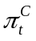 | 3.571 | 34.17 | 1.705 | 0.012 | 0.743 | 0.799 | 8.67 | 6.224 | 0.61 | 0.063 | 0.132 | 2.096
 | 17.576 | 57.625 | 5.513 | 0.189 | 4.335 | 6.33 | 25.783 | 14.829 | 6.434 | 0.897 | 0.543 | 5.489
 | 0 | 0.18 | 0.896 | 0 | 0 | 0 | 68.748 | 9.255 | 0.097 | 0.005 | 0.063 | 2.719
 | 1.222 | 0.535 | 2.379 | 0.031 | 0.103 | 0.702 | 84.23 | 20.14 | 0.545 | 0.135 | 0.25 | 6.744
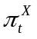 | 1.024 | 0.124 | 0.102 | 0.003 | 0.15 | 0.308 | 88.844 | 0.14 | 0.054 | 0.022 | 0.016 | 0.044
 | 5.543 | 1.547 | 0.556 | 0.04 | 0.979 | 1.96 | 96.214 | 0.779 | 1.033 | 0.256 | 0.084 | 0.241
 | 0 | 0 | 2.142 | 0.017 | 0 | 0.271 | 38.587 | 25.247 | 0.646 | 0.001 | 0.212 | 8.917
 | 0.681 | 0.092 | 4.598 | 0.119 | 0.763 | 2.874 | 57.276 | 39.882 | 2.191 | 0.128 | 0.72 | 15.245
csn | 0 | 0.043 | 0.134 | 1.826 | 14.968 | 12.76 | 18.079 | 6.294 | 7.847 | 0.051 | 0.179 | 1.959
 | 2.364 | 0.654 | 1.597 | 3.226 | 25.775 | 25.666 | 33.383 | 17.875 | 17.976 | 0.582 | 0.446 | 5.607
gsn | 0 | 0.033 | 1.931 | 23.496 | 9.225 | 2.113 | 20.566 | 0.232 | 6.079 | 0.001 | 0.137 | 0.477
 | 0.793 | 0.832 | 5.88 | 35.953 | 17.869 | 8.912 | 36.984 | 4.273 | 19.64 | 0.149 | 0.342 | 2.705
isn | 0 | 0 | 0 | 0.29 | 75.713 | 1.411 | 1.213 | 2.05 | 5.013 | 0.016 | 0.081 | 0.845
 | 0.853 | 0.241 | 0.717 | 0.587 | 85.002 | 4.607 | 3.265 | 5.842 | 9.602 | 0.146 | 0.226 | 2.076
igsn | 0 | 0.27 | 1.109 | 38.167 | 4.016 | 0.425 | 4.246 | 1.032 | 22.631 | 0 | 0.063 | 0.561
 | 0.449 | 0.937 | 3.706 | 51.212 | 9.138 | 3.681 | 10.138 | 4.276 | 40.491 | 0.072 | 0.196 | 2.221
tbyn | 0 | 0 | 0.901 | 0.085 | 0.642 | 1.116 | 44.177 | 16.036 | 0.083 | 0.001 | 0.652 | 5.613
 | 0.338 | 0.347 | 2.886 | 0.223 | 2.229 | 3.725 | 73.333 | 36.526 | 0.532 | 0.078 | 1.152 | 12.684
L | 21.579 | 0.067 | 1.515 | 0.366 | 6.236 | 0 | 1.953 | 3.985 | 12.121 | 5.28 | 0.309 | 1.659
 | 45.533 | 0.843 | 6.329 | 0.904 | 15.011 | 5.694 | 5.603 | 9.852 | 25.13 | 25.225 | 0.742 | 3.808
ws | 48.197 | 4.998 | 0 | 0.564 | 1.021 | 0.183 | 6.136 | 0.009 | 1.51 | 1.23 | 0 | 0
 | 64.433 | 12.606 | 0.606 | 1.265 | 7.076 | 9.329 | 14.21 | 4.991 | 7.356 | 10.785 | 0.05 | 1.738
trw | 3.097 | 0.008 | 0.202 | 74.653 | 0.847 | 0 | 0.29 | 0.425 | 1.538 | 0.685 | 0.048 | 0.188
 | 9.492 | 0.156 | 1.148 | 88.97 | 3.021 | 1.053 | 1.147 | 2.085 | 5.138 | 4.753 | 0.158 | 0.754
csn^{k} | 45.779 | 2.634 | 0 | 7.135 | 3.206 | 0 | 7.538 | 1.047 | 0.621 | 0.306 | 0 | 0.278
 | 61.687 | 7.757 | 1.456 | 12.663 | 10.26 | 4.994 | 16.051 | 7.389 | 3.391 | 4.61 | 0.116 | 2.633
csn^{i} | 3.395 | 0 | 0.042 | 1.486 | 12.13 | 11.791 | 14.82 | 5.237 | 8.476 | 0 | 0.192 | 1.369
 | 16.511 | 0.1 | 1.283 | 2.729 | 22.015 | 27.941 | 29.276 | 14.843 | 18.869 | 0.181 | 0.46 | 4.343

TABLE A3.4. Posterior variance decomposition – 90% Highest Probability Interval. (Conditional 4-step ahead)
 | Wage mark-up | Price mark-up | Monetary policy | Fiscal policy | Investment | Consumption | Trade | Risk premium | TFP | Labour demand | Rest of the world | Foreign monetary shock
 | 0.573 | 0.791 | 3.989 | 1.233 | 11.317 | 1.969 | 16.297 | 4.078 | 24.331 | 0.059 | 0.313 | 2.249
 | 3.456 | 2.297 | 8.86 | 2.439 | 20.285 | 9.452 | 28.698 | 10.332 | 41.259 | 0.419 | 0.664 | 5.14
 | 2.299 | 2.085 | 11.408 | 0.322 | 5.87 | 8.309 | 2.789 | 10.828 | 2.895 | 0.031 | 0.669 | 3.673
 | 18.312 | 9.625 | 26.407 | 0.787 | 15.265 | 20.109 | 10.1 | 21.801 | 12.391 | 0.728 | 1.587 | 8.304
 | 12.938 | 19.846 | 1.823 | 0.052 | 2.119 | 6.043 | 0.697 | 2.039 | 1.909 | 0.219 | 0.234 | 0.608
 | 43.949 | 45.58 | 6.288 | 0.457 | 10.044 | 19.083 | 3.278 | 7.909 | 11.466 | 2.039 | 0.94 | 2.783
 | 10.347 | 15.697 | 2.096 | 0.029 | 1.754 | 3.821 | 5.893 | 6.232 | 0.841 | 0.181 | 0.226 | 1.829
 | 37.18 | 34.37 | 6.671 | 0.337 | 8.174 | 14.525 | 20.164 | 14.819 | 8.903 | 1.82 | 0.93 | 4.991
 | 0.418 | 0.212 | 0.837 | 0.003 | 0.064 | 0.174 | 68.001 | 9.48 | 0.117 | 0.018 | 0.194 | 2.457
 | 3.095 | 0.724 | 2.309 | 0.032 | 0.391 | 0.873 | 83.211 | 19.887 | 0.733 | 0.247 | 0.479 | 6.31
 | 3.09 | 0.222 | 0.244 | 0.006 | 0.284 | 0.805 | 76.307 | 0.312 | 0.109 | 0.057 | 0.031 | 0.087
 | 13.409 | 1.921 | 1.201 | 0.089 | 2.107 | 4.647 | 91.057 | 1.691 | 2.204 | 0.629 | 0.174 | 0.48
 | 0.013 | 0.018 | 2.244 | 0.02 | 0.039 | 0.342 | 37.883 | 24.073 | 0.656 | 0.002 | 0.276 | 9.046
 | 0.724 | 0.168 | 4.703 | 0.12 | 0.835 | 2.908 | 56.28 | 38.621 | 2.181 | 0.13 | 0.788 | 15.385
csn | 0.003 | 0.011 | 0.088 | 0.865 | 12.445 | 19.81 | 6.602 | 8.716 | 14.58 | 0.052 | 0.412 | 2.173
 | 2.984 | 0.211 | 0.817 | 1.843 | 24.593 | 37.484 | 13.859 | 19.559 | 28.388 | 0.795 | 0.961 | 4.491
gsn | 0.092 | 0.273 | 1.734 | 17.113 | 7.506 | 2.047 | 11.323 | 0.325 | 21.707 | 0.012 | 0.283 | 0.49
 | 3.5 | 1.123 | 5.232 | 30.961 | 16.112 | 11.066 | 24.777 | 3.065 | 39.201 | 0.421 | 0.687 | 1.766
isn | 0.001 | 0 | 0.001 | 0.176 | 66.502 | 2.281 | 0.771 | 2.449 | 6.737 | 0.021 | 0.203 | 0.962
 | 1.162 | 0.183 | 0.273 | 0.477 | 80.88 | 8.617 | 2.03 | 7.513 | 15.264 | 0.224 | 0.509 | 2.293
igsn | 0.025 | 0.038 | 0.152 | 78.792 | 0.497 | 0.034 | 0.294 | 0.189 | 6.678 | 0.001 | 0.018 | 0.067
 | 0.517 | 0.224 | 0.856 | 90.025 | 2.073 | 0.981 | 0.909 | 0.923 | 15.324 | 0.043 | 0.093 | 0.412
tbyn | 0.01 | 0.003 | 0.93 | 0.126 | 1.105 | 3.608 | 23.475 | 30.158 | 0.265 | 0.003 | 2.229 | 9.295
 | 0.837 | 0.119 | 2.472 | 0.37 | 4.228 | 9.317 | 40.287 | 50.312 | 0.773 | 0.093 | 3.213 | 13.586
L | 38.021 | 0.128 | 1.087 | 0.281 | 5.169 | 0.001 | 1.606 | 3.627 | 7.943 | 2.374 | 0.349 | 1.349
 | 66.582 | 0.941 | 5.311 | 0.787 | 14.072 | 5.574 | 4.387 | 9.24 | 19.422 | 9.483 | 0.845 | 3.188
ws | 63.646 | 1.407 | 0.125 | 0.099 | 0.228 | 3.877 | 0.846 | 0.118 | 0.806 | 1.757 | 0.004 | 0.042
 | 83.758 | 4.429 | 1.143 | 0.29 | 1.783 | 15.08 | 2.346 | 2.051 | 3.788 | 12.747 | 0.061 | 0.466
trw | 18.638 | 0.057 | 0.534 | 30.644 | 2.706 | 0.001 | 0.763 | 1.95 | 4.302 | 1.148 | 0.203 | 0.681
 | 40.738 | 0.53 | 2.966 | 57.057 | 8.248 | 3.122 | 2.471 | 5.831 | 11.843 | 5.504 | 0.545 | 1.863
csn^{k} | 72.439 | 0.548 | 0.047 | 1.848 | 0.779 | 0.634 | 1.067 | 0.719 | 0.368 | 0.173 | 0.003 | 0.098
 | 86.666 | 2.255 | 0.357 | 4.939 | 4.095 | 6.975 | 2.759 | 3.99 | 3.023 | 4.799 | 0.135 | 0.993
csn^{i} | 6.455 | 0 | 0.067 | 0.731 | 10.318 | 14.873 | 4.802 | 7.466 | 13.487 | 0.001 | 0.378 | 1.623
 | 25.02 | 0.082 | 0.768 | 1.554 | 21.369 | 32.976 | 11.461 | 16.996 | 25.968 | 0.18 | 0.87 | 3.661

TABLE A3.5. Posterior variance decomposition – 90% Highest Probability Interval. (Unconditional variance)
 | Wage mark-up | Price mark-up | Monetary policy | Fiscal policy | Investment | Consumption | Trade | Risk premium | TFP | Labour demand | Rest of the world | Foreign monetary shock
 | 1.959 | 0.811 | 4.017 | 1.215 | 10.692 | 2.284 | 15.606 | 4.097 | 24.094 | 0.075 | 0.375 | 2.693
 | 5.595 | 2.347 | 8.745 | 2.37 | 19.044 | 10.292 | 27.371 | 10.282 | 40.416 | 0.528 | 0.745 | 5.542
 | 12.237 | 0.339 | 1.545 | 0.236 | 4.011 | 9.181 | 2.477 | 7.865 | 5.35 | 0.087 | 0.355 | 1.331
 | 41.207 | 1.514 | 3.808 | 0.948 | 20.184 | 34.775 | 6.814 | 18.296 | 17.481 | 1.318 | 1.155 | 4.039
 | 25.437 | 9.128 | 1.08 | 0.066 | 1.531 | 3.697 | 0.718 | 2.321 | 2.593 | 0.336 | 0.129 | 0.349
 | 60.978 | 22.619 | 4.379 | 0.355 | 11.451 | 19.403 | 3.236 | 7.696 | 16.839 | 3.644 | 0.586 | 1.665
 | 23.333 | 7.158 | 1.042 | 0.053 | 1.411 | 3.423 | 3.156 | 4.054 | 2.109 | 0.312 | 0.112 | 0.834
 | 57.303 | 17.748 | 4.454 | 0.314 | 11.078 | 18.272 | 10.584 | 10.799 | 15.644 | 3.459 | 0.562 | 2.783
 | 3.152 | 0.204 | 0.809 | 0.021 | 0.365 | 0.951 | 58.345 | 7.859 | 0.438 | 0.051 | 0.211 | 2.272
 | 12.386 | 0.655 | 2.136 | 0.093 | 2.826 | 4.418 | 75.868 | 17.296 | 3.193 | 0.732 | 0.46 | 5.673
 | 7.938 | 0.173 | 0.337 | 0.018 | 0.565 | 1.125 | 52.166 | 0.856 | 0.737 | 0.155 | 0.049 | 0.126
 | 29.026 | 1.318 | 1.503 | 0.125 | 5.322 | 8.741 | 75.642 | 3.326 | 7.432 | 1.812 | 0.213 | 0.56
 | 0.527 | 0.023 | 2.136 | 0.033 | 0.268 | 0.946 | 36.767 | 23.047 | 0.937 | 0.007 | 0.5 | 9.345
 | 2.86 | 0.191 | 4.478 | 0.145 | 1.645 | 3.847 | 54.777 | 37.199 | 2.561 | 0.212 | 1.005 | 15.48
csn | 0.41 | 0.006 | 0.014 | 0.085 | 3.814 | 1.726 | 0.641 | 1.236 | 60.317 | 0.087 | 0.031 | 0.138
 | 8.179 | 0.031 | 0.107 | 0.491 | 20.661 | 10.162 | 2.647 | 6.681 | 83.618 | 0.706 | 0.217 | 0.768
gsn | 3.878 | 0.142 | 0.762 | 12.681 | 4.431 | 1.603 | 5.727 | 0.257 | 32.794 | 0.152 | 0.129 | 0.239
 | 16.231 | 0.616 | 2.784 | 26.87 | 11.245 | 7.434 | 15.604 | 1.571 | 53.367 | 1.415 | 0.411 | 0.923
isn | 0.423 | 0.002 | 0.007 | 0.028 | 7.682 | 0.237 | 0.102 | 0.134 | 56.755 | 0.054 | 0.011 | 0.049
 | 8.799 | 0.029 | 0.076 | 0.346 | 30.473 | 5.829 | 0.788 | 2.342 | 84.711 | 0.585 | 0.103 | 0.368
igsn | 0.036 | 0.004 | 0.016 | 90.311 | 0.089 | 0.009 | 0.034 | 0.02 | 1.151 | 0.001 | 0.002 | 0.011
 | 0.898 | 0.052 | 0.201 | 98.44 | 0.623 | 0.304 | 0.267 | 0.23 | 7.327 | 0.055 | 0.027 | 0.115
tbyn | 0.709 | 0.002 | 0.413 | 0.102 | 0.786 | 3.452 | 18.037 | 35.407 | 0.277 | 0.001 | 1.944 | 6.04
 | 5.843 | 0.065 | 1.234 | 0.508 | 4.834 | 13.513 | 32.705 | 60.979 | 1.019 | 0.083 | 2.942 | 9.509
L | 41.385 | 0.01 | 0.013 | 0.013 | 0.487 | 0.01 | 0.069 | 0.206 | 6.033 | 2.066 | 0.009 | 0.028
 | 87.536 | 0.101 | 0.431 | 0.119 | 7.752 | 0.685 | 0.52 | 1.601 | 37.96 | 14.695 | 0.076 | 0.228
ws | 17.045 | 0.214 | 0.133 | 0.018 | 0.12 | 1.567 | 0.201 | 0.128 | 0.223 | 23.587 | 0.011 | 0.051
 | 63.013 | 1.058 | 0.923 | 0.076 | 0.656 | 6.893 | 0.638 | 0.712 | 1.053 | 72.265 | 0.083 | 0.256
trw | 39.387 | 0.01 | 0.013 | 0.2 | 0.48 | 0.021 | 0.068 | 0.19 | 5.986 | 1.627 | 0.007 | 0.027
 | 86.046 | 0.099 | 0.419 | 3.75 | 7.622 | 0.664 | 0.514 | 1.521 | 36.937 | 14.032 | 0.072 | 0.22
csn^{k} | 59.105 | 0.084 | 0.072 | 0.312 | 0.217 | 0.591 | 0.171 | 0.118 | 3.104 | 3.975 | 0.004 | 0.022
 | 85.889 | 0.446 | 0.456 | 1.375 | 2.609 | 3.019 | 0.539 | 0.911 | 12.521 | 25.205 | 0.033 | 0.16
csn^{i} | 2.467 | 0.007 | 0.029 | 0.084 | 3.758 | 1.575 | 0.553 | 0.91 | 52.13 | 0.071 | 0.032 | 0.105
 | 23.495 | 0.048 | 0.179 | 0.425 | 19.421 | 8.743 | 2.283 | 5.982 | 80.318 | 1.42 | 0.195 | 0.632

References

Juillard, M., Kamenik, O., Kumhof, M., Laxton, D., 2007. Measures of Potential Output from an Estimated DSGE Model of the United States. mimeo.
Schorfheide, F., 2004. Notes on Model Evaluation. Department of Economics, University of Pennsylvania.
Sims, C., 2003. Matlab Procedures to Compute Marginal Data Densities for VARs with Minnesota and Training Sample Priors. Department of Economics, Princeton University.
Sims, C., Zha, T., 1998. Bayesian methods for dynamic multivariate models. International Economic Review 49, 949-968.

